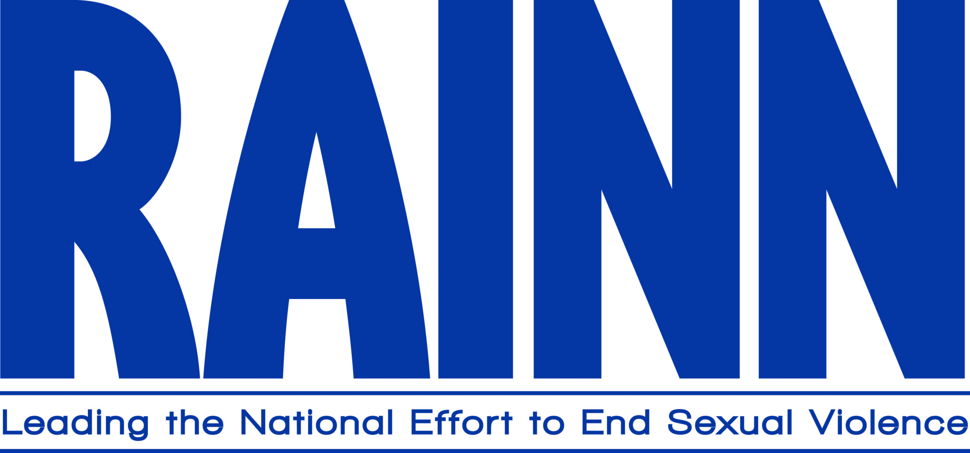

Department: General Administration

Position: HR Training Design and Development Manager

Reporting to: Director, Human Resources and Administration

The HR Training Design and Development Manager will serve as both a strategic and tactical member of the Human Resources Department. The position will be responsible for conducting needs assessments and using adult learning methodology to design, develop, enhance, and deliver new and existing training programs (Human Resources, Interpersonal and Leadership Development) to support RAINN’s goals, objectives, and visitor services.

Essential Duties and Responsibilities:

Training Assessment
- Conduct needs assessments to determine desired/necessary training solutions.
- Collaborate with RAINN stakeholders to align and customize training needs to support all departments, staff and company initiatives
- Collaborate and work in cooperation with Victim Services Training Team
Training Design & Development
- Design and develop training in various formats including, instructor-led training, virtual instructor led-training, e-learning, self-directed training, blended training.
- Develop training materials including experiential learning plans, presentation materials, participant materials and as appropriate, e-learning programs.
- Manage and coordination with third-party vendors/consultants as needed
Training Delivery
- Deliver training/learning interventions that both engage and energize the learner and produce desired outcomes.
- Utilize learning delivery mechanisms and methodologies that include lectures, kinesthetic class exercises, role plays, simulations, technology-delivered training or e-learning technology support tools.
- As required, support and participate in the On-Boarding activities for staff
Training Evaluation
- Create measures to determine effectiveness, application and value of training delivered
- Review with departments, the impact of individual programs and identify follow-on training initiatives/interventions
- Perform Gap analysis and make recommendations to enhance training experience

Communication
- Distribute, in partnership with RAINN Communications, information about human resources initiatives
- Utilizing print and digital tools, create and assist in publishing HR newsletters, calendars, intranet posts
- Select, design and facilitate organizational development interventions, e.g., focus groups, team meetings.
- Facilitate employee engagement initiatives identified through surveys, focus groups and discussion. Position will work in tandem with VS Training Team.
Position Requirements:

To perform this job successfully, an individual must be able to perform each essential function satisfactorily. The requirements listed below are representative of the knowledge, skill and/or ability required:

- Minimum Bachelor’s Degree with emphasis in one or more of the following disciplines: Training, Curriculum Design, Training Technology, Organizational Development, Communications, Human Resources.
- 4+ years of experience or equivalent combination of education and related work experience.
- Experience and skill using e-learning authoring tools such as Articulate Storyline 360, Articulate Rise 360, Adobe Captivate, Eucidate, etc.
- Experience and skill using PowerPoint, Word, Excel.
- Experience using WebEx, Zoom or other web-conferencing tools.
- Experience using Learning Management Systems.
- Deep appreciation for visual design.
- Program management experience from creation to evaluation of customized programs or curricula.
- Nationally recognized training and assessment accreditations and certifications a plus.
- Works collaboratively/effectively in a functional organizational structure, managing by influence not authority.
- Team player who embraces change.
- Self-starter; high degree of motivation to deliver a quality product.
- Personal commitment to RAINN’s mission and values.
- Discretion when dealing with sensitive information and ability to discuss issues surrounding sexual violence.
- Must successfully complete a criminal background check (administered by RAINN).

When you work for RAINN, you're joining a team of experts and professionals who stand up for survivors of sexual violence every day. Your job is important--and so are you! RAINN will not discriminate against any employee or applicant for employment because of race, color, creed, religion, national origin, gender, sexual orientation, age, gender, identity, genetic information, disability or protected veteran status. RAINN is committed to maximizing the diversity of its organization and depends on a diverse staff to carry out its mission, and encourages all candidates to apply.
EOE/M/F/D/V

